Introduction: This presentation is meant for a small group, in a lab-style setting and can be self-led or instructor led. It may work best as one “station” of lab activities or as a supplement to class time and/or material. It introduces the concept of stormwater management, what MS4 and Combined Sewer Systems are and encourages students to discover ways of protecting stormwater that enters their home systems.
Objectives: Students will be introduced to the concept of storm water runoff and create their own storm drain system inside of the Augmented Reality Sandbox (ARS) unit by using models of different man-made structures.
Two Important Rules for Using the Sandbox
Keep the sand in the box
Please don’t touch the computer or projector to insure proper settings

Supporting Information for Teachers and Students:
In this lesson we will learn about stormwater management practices used in watersheds. Many cities have a Municipal Separate Storm Sewer System (MS4) in place for stormwater runoff. An MS4 is a separate sewer system that is just for stormwater from rain, snow and ice melt. This system of pipes and drains are used to carry stormwater back to local water bodies and help prevent flooding of our streets, sidewalks, yards and homes. Combined sewer systems (CSS) are sewers that are designed to collect rainwater runoff, domestic sewage, and industrial wastewater in the same pipe. CSS transport residential wastewater to a sewage treatment plant, where it is treated and then discharged to a water body. In heavy rain events the volume of wastewater can exceed the holding capacity of the treatment plant causing combined sewer overflows (CSO). When a CSO occurs, it results in untreated stormwater and wastewater, which contains treated and untreated human waste, industrial waste and other toxic debris, that discharges directly into rivers, lakes and other water bodies.
There are two types of surfaces that affect water flow; the first are impervious surfaces, hard surfaces that do not allow water to soak in, like sidewalks, parking lots and roads; second are permeable surfaces, which allow water to pass through and be absorbed like a sponge, like gardens, forests and grassed areas. MS4’s help prevent erosion and destruction of our landscapes and green spaces. If stormwater wasn’t removed with human help, important topsoil would be carried away. Topsoil is the foundation of our ecosystem. If we allowed all the topsoil to be carried away by water and wind erosion, we would not be able grow food, support trees for oxygen, or build homes for shelter which are essential for human life. You can help your MS4 by choosing not to litter, picking up pet waste, and collecting yard leaves and trimmings. Education on recycling of paints, motor oil, toxic chemicals and yard fertilizers can ensure that only rain goes down our drains.

Stormwater Management Worksheet
This activity introduces the concepts of MS4’s (Municipal Separate Storm Sewer Systems) and Combined Sewer Systems used to improve water quality from stormwater runoff.
Presentation Style:
Classroom activity
Using ARS
Time: 10-15 minutes
Age: 6th Grade and up
Group Size: 2-5

Worksheet Instructions:

Complete questions #1-#7 on Stormwater Management worksheet BEFORE working hands-on at the ARS unit. Then in small groups complete the worksheet as you experiment with the ARS unit.
After it rains in cities, where does the water go? The stormwater EPA diagram below can help us answer this question. We know that watersheds are areas of land that feed all the water to a single point, or outlet. Now let’s learn about MS4 and Combined Sewer Systems part in draining water from a city.
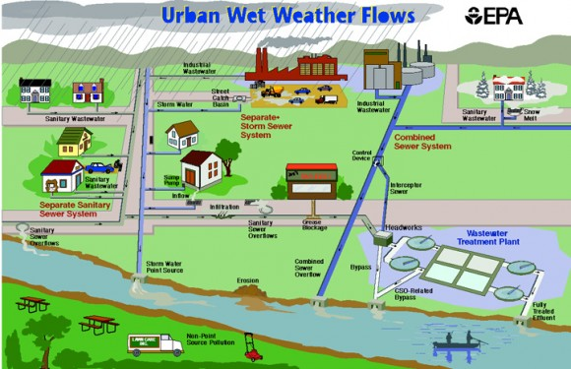

Questions to Answer Before Using the Augmented Reality Sandbox

- What is an MS4 and how does the system work?

- What are some permeable surfaces on the map above? Place a on the permeable surfaces.

- What are some impervious surfaces on the map above? Place an X on impervious surfaces.

- What is a Combined Sewer System?

- Using the diagram above, how many combined sewer system pipes can you count that lead to the wastewater treatment plant?

- We don’t want to pollute our nearby waterbodies. Which of the following do you want to help keep out of stormwater drains? Circle all that apply.

  - litter b. snow c. motor oil d. rainwater e. paint f. pet waste g. leaves

- What is a Combined Sewer Overflow caused by?

- Where does most of the stormwater from Steuben County eventually flow?
  - Lake Michigan
  - Lake Superior
  - Gulf of Mexico

Group lesson hands-on experimentation with ARS unit:
- Make a mound of sand with a gradual slope and add props from the box (houses, trees, roadways, etc.) to make a city landscape. Then make tunnels with your finger or tool to represent MS4 pipes. (See map above for ideas). You may use the back of this sheet for extra space for answers.
- After the tunnels have been formed, make a shallow lake at the bottom of your cityscape to represent a water body.
- Have the group make it rain over the watershed by holding their hands flat over the sand. Let’s talk about what happens when stormwater falls onto the cityscape.

Where does the water flow?

What happens to the soil when water is moving quickly down a steep slope?

Is erosion good or bad? Why or why not?

What can your team do to stop the erosion?

- Now replicate your cityscape and do not add tunnels. What are the differences?

Where does the water flow?

Does erosion still happen?

What can be done to help the water puddles infiltrate the landscape?

After you’ve completed your stormwater cityscape please flatten the sand and put props back in box for the next group. Thank you from your friends at Steuben County SWCD.
Optional: Take a picture of your watershed and submit to your teacher with this worksheet. Teachers, if permitted, forward pictures to the Steuben County SWCD so we can see the ARS unit in use, and we will post it on our website and Facebook page.

