Intro to Watershed Worksheet
This activity introduces the concept of watersheds to students and creates a hands-on activity for everyone to use the Augmented Reality Sandbox (ARS) unit.
Presentation Style:
Classroom activity
Using ARS
Time: 15 minutes
Age: 6th Grade or older
Group Size: 2-5

Introduction: This presentation is meant for a small group, in a lab-style setting and can be self-led or instructor led. It may work best as one “station” of lab activities or as a supplement to class time and/or material. It introduces the concept of watersheds and encourages the students to discover properties of watersheds by creating their own watershed in the Augmented Reality Sandbox (ARS)unit.

Objectives: Students will be introduced to the concept of watersheds and create their own watershed inside of the ARS unit.
Two Important Rules for Using the Sandbox
Keep the sand in the box
Don’t touch the computer or projector to insure proper settings

Supporting Information for Teachers and Students:
A watershed is an area of land that feeds all the water running under it and draining off it to a single outlet. Watersheds can be relatively large (e.g. the Mississippi River Basin) or relatively small (e.g. the area that drains to a local ditch). Watersheds situated right next to each other may funnel water opposite directions, or they may connect to form a larger watershed with a larger outlet downstream. Topography is the study of the shape, elevation changes and features of landforms. Landforms include anything that physically impacts the area. Landform examples include mountains, hills, valleys, lakes, oceans, rivers, cities, volcanos, and roads. The elevation, or height, of landforms is recorded as part of topography. Elevation is recorded in reference to sea level (the surface of the ocean). The Earth’s highest elevation is at the summit of Mt. Everest which measures 29,035 feet above sea level. The Earth’s lowest land elevation is the Dead Sea which measures 1,385 feet below sea level.
Student Instructions:
Complete questions #1-#7 on Intro to Watershed Worksheet BEFORE working hands on at the ARS unit. Then in small groups complete the worksheet as you experiment with the ARS unit.

Worksheet Instructions:
After it rains, where does the water go? Watersheds can help us answer this question. So, if you live in Steuben County the rainwater that hits the roof of your house, school, and puddles up in your yard eventually flows into Lake Michigan or Lake Erie. The St. Joseph River Watershed covers about 70% of Steuben County and The Western Lake Erie Basin covers the remaining 30%.
Below are maps of the St. Joseph River and the Western Lake Erie Basin watersheds.
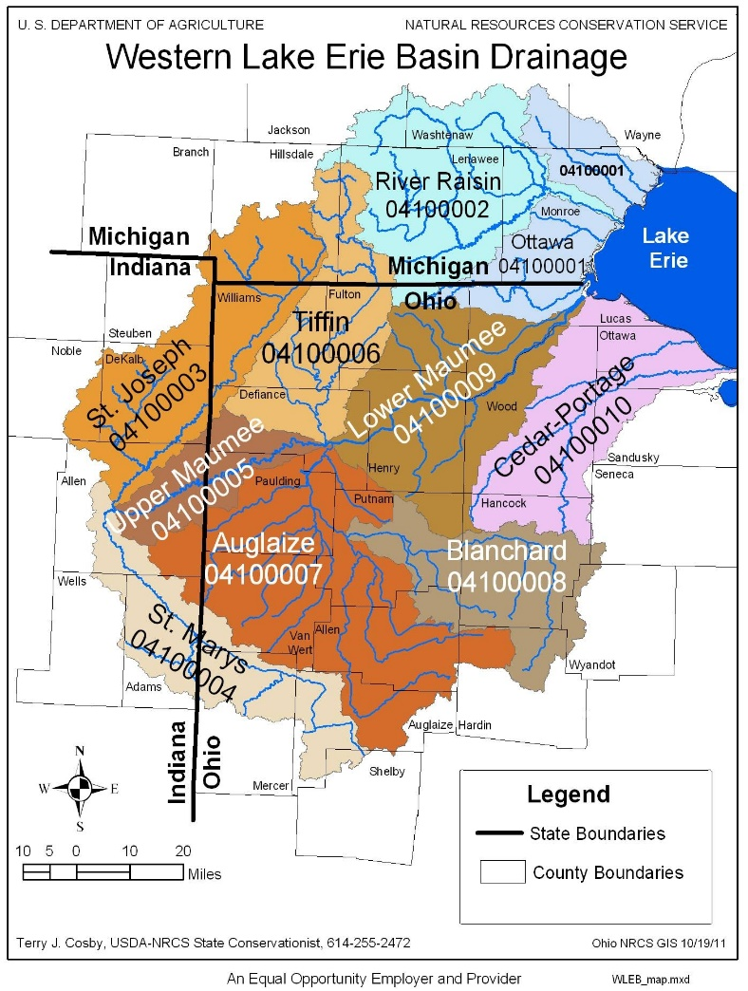
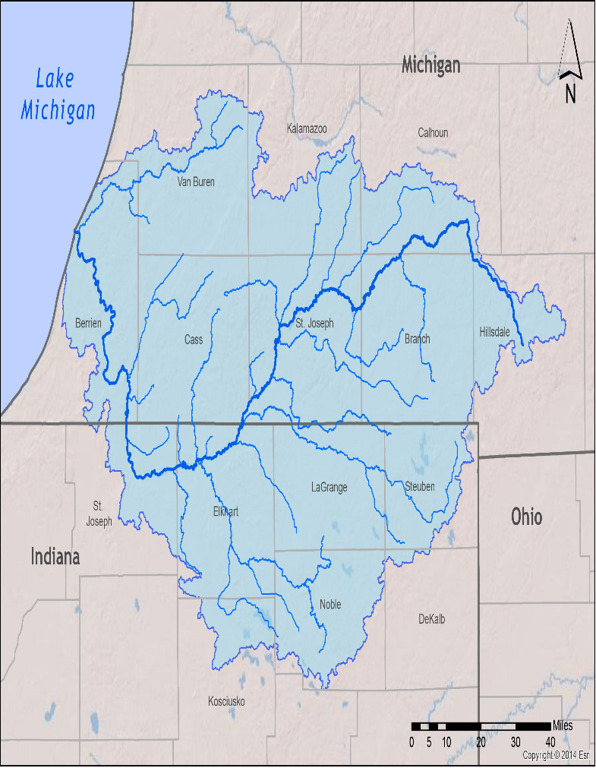

Questions to Answer Before Using the Augmented Reality Sandbox

- Using the maps above where is your school located at in Steuben County?

- Where does all the flowing water below ground and over the ground, in the St. Joe River Watershed drain to?
  - Lake Michigan b. Lake Erie c. Gulf of Mexico d. Dead Sea

- What is a watershed?

- The study of the shape, elevation changes and features of landforms is called_____________?
  - Topography b. Ecology c. Geology d. Botany

- What are some examples of landforms?

- The recorded height of landforms in reference to sea level is known as what?

- What is the highest elevation point on Earth?

- The lowest elevation point on Earth?

Group lesson hands on experimentation with ARS unit:
- Review the definition of watershed at the beginning of this worksheet. Watershed boundaries are defined by topography.
- Using the ARS unit, create a watershed with mountains, ridges or valleys. Then add rivers and lakes that lead to a single water outlet, such as rivers and lakes.
- Students may use hands or tools in the toy box to assist them with creating their watersheds.
- Add houses, trees, cars, animals or other items for visual effect.
- In the box below, draw the shape of your watershed and include an “X” water outlet of your watershed.

- To see how rain impacts your watershed, place your hands under the camera and make it rain. Does all the rainwater that falls onto your watershed go to the same outlet? If not, where is the rain in your watershed draining to? ex: Valley, streams or ditch.

After you’ve completed your stormwater cityscape please flatten the sand and put props back in toy box for the next group. Thank you from your friends at Steuben County SWCD.
Optional: Take a picture of your watershed and submit to your teacher with this worksheet. Teachers, if permitted, forward pictures to the Steuben County SWCD so we can see the ARS unit in use, and we will post it on our website and Facebook page.

