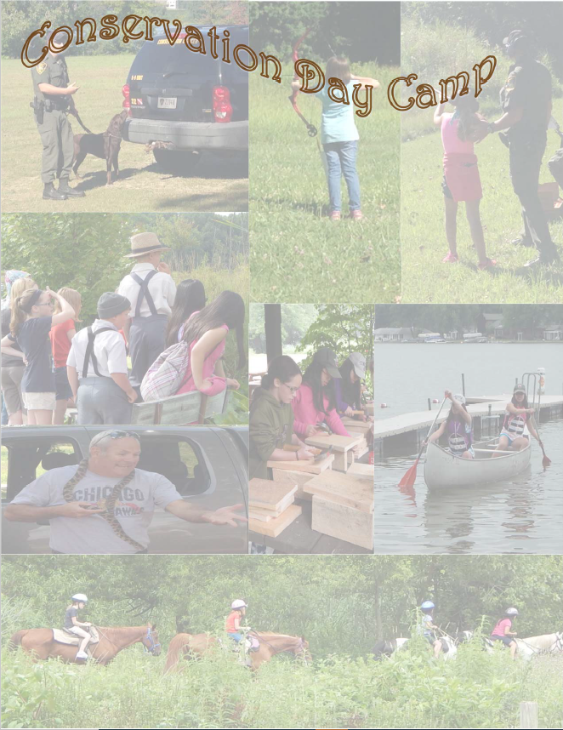

The Northeast Indiana Conservation Districts are offering three individual Conservation Day Camps this summer for your children to enjoy! Each camp costs $10 per child from ages 9-13. The camp is from 9:00 a.m. – 2:30 p.m. with lunch and supplies provided.

**Thursday, June 23, 2022 – ParGil Learning Center**

2335 N. State Rd. 9

LaGrange, Indiana

**Tuesday, July 12, 2022 – Pokagon State Park**

450 Ln 100 Lake James

Angola, Indiana

**Tuesday, August 2, 2022 – Camp Whitley**

4305 W. Camp Whitley Rd.

Columbia City, Indiana



**Registration Form on back**

**or call your local SWCD to register**

DeKalb Co. SWCD (260) 925-5620 x 3

LaGrange Co. SWCD (260) 463-3166 x 3

Steuben Co. SWCD (260) 665-3211 x 3

Whitley Co. SWCD (260) 244-6266 x 3

*Conservation Day Camps*

The Northeast Indiana Conservation Districts are offering three individual Conservation Day Camps this summer for your children to enjoy! Each Day Camp costs $10.00 per child ages 9 to 13 years old. The camp runs from 9:00 a.m. to 2:30 p.m., with lunch and supplies provided.

***Campers Information***

First Name: Last Name: Age:

Address:

City: State: Phone Number: ( )

Allergies (please list all):

Medications (please list all):

Food Restrictions (please list all):

***Parental/Guardian Information***

First Name: Last Name:

Phone Number: ( )

***Emergency Contact***

First Name: Last Name:

Phone Number: ( )

* Please mark all the dates you would like your child to attend.
* Registration must be submitted one (1) week prior to day of camp.
* Please make checks payable to the SWCD office you will be registering through.

______ Thursday, June 23, 2022 – ParGil Learning Center, LaGrange, Indiana

______ Tuesday, July 12, 2022 – Pokagon State Park, Angola, Indiana

______ Tuesday, August 4, 2022 – Camp Whitley, Columbia City, Indiana

***Mail registration form or call your local SWCD to register***

**DeKalb Co. SWCD** (260) 925-5620 ext. 3 **Steuben Co. SWCD** (260) 665-3211 ext. 3

942 W. 15th St., Auburn, IN 46706 1220 N 200 W, Suite L, Angola, IN 46703

**LaGrange Co. SWCD** (260) 463-3166 ext. 3 **Whitley Co. SWCD** (260) 244-6266 ext. 3

910 S. Detroit St., LaGrange, IN 46761 788 W. Connexion Way, Ste C, Columbia City, IN 46725